Lab -3 -b

Praneesh R V

CB.SC.U4CYS23036

Understanding /etc/passwd

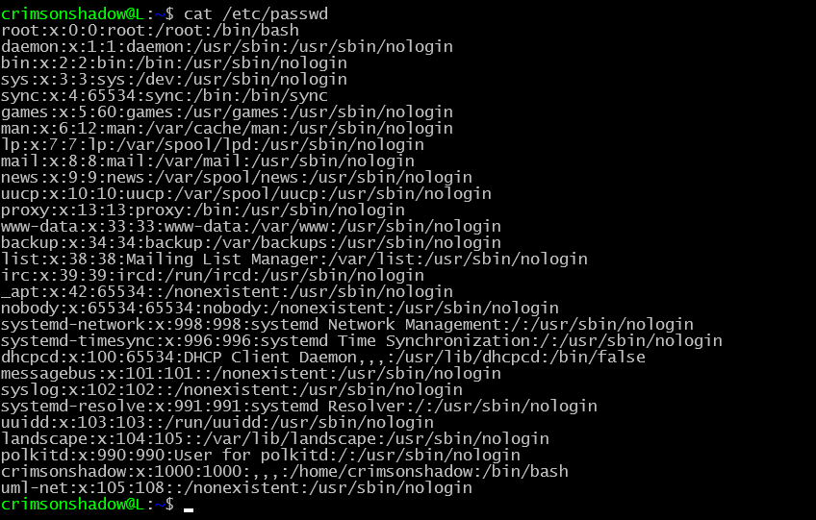

etc/group

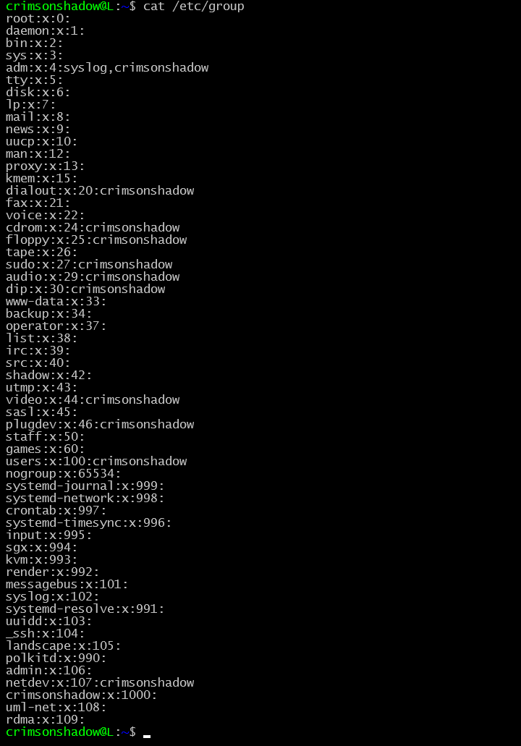

Changing password

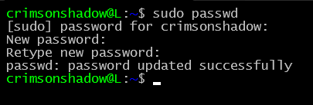

Limits.conf

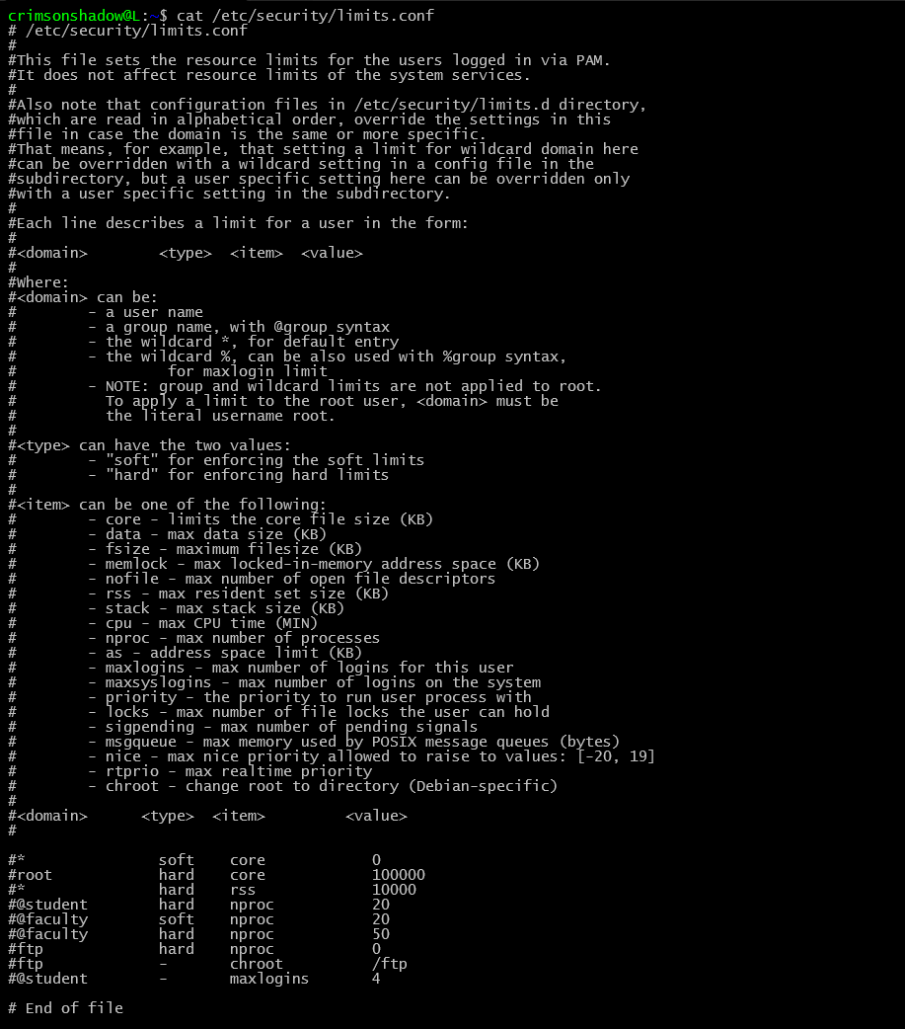

Set password policy



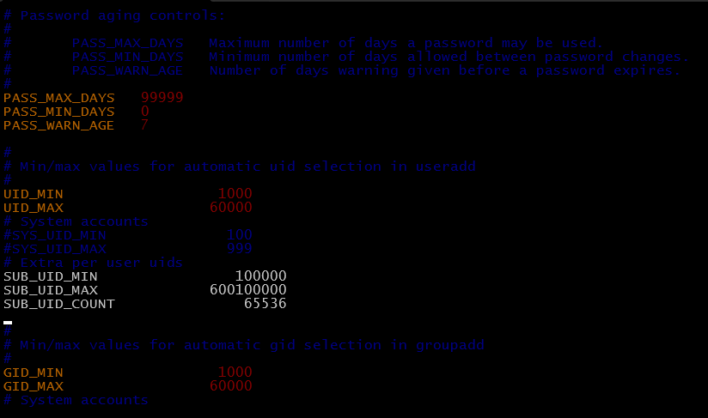

6 switch users and sudo access

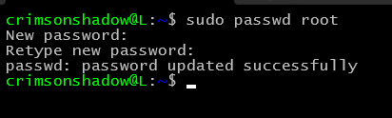

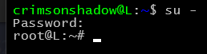

New user

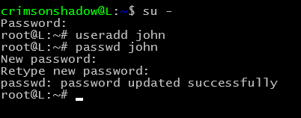

Users of group sudo

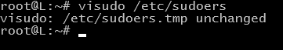

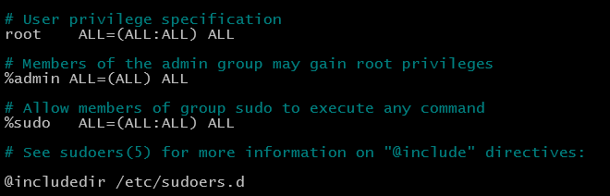

Adding john to sudo

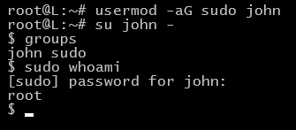

User account management

Removing john



Adding group car



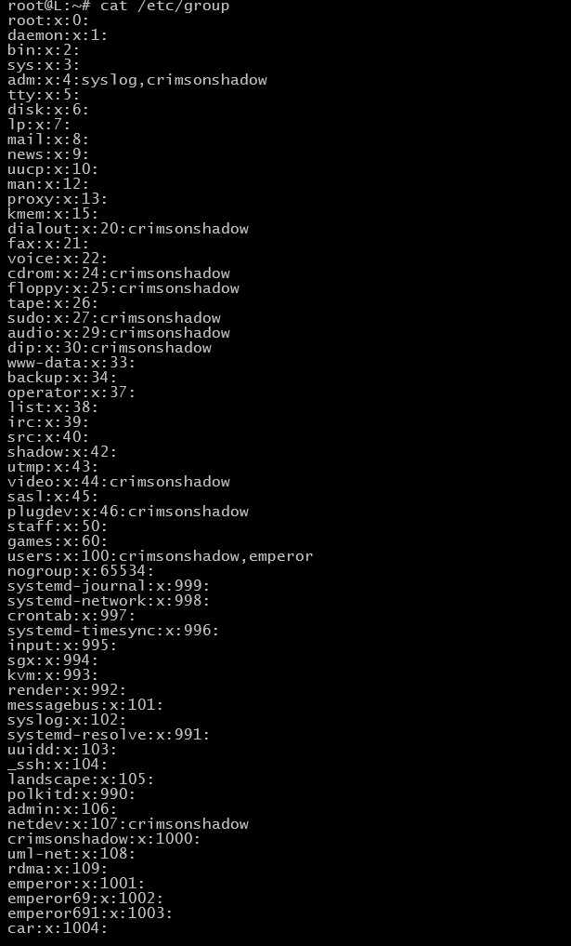

Deleting group wheel



Modifying user

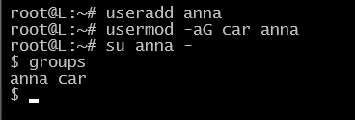

Useraccounts in linux

Adding user in different home directory

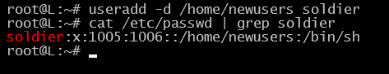

Adding user with specific user id

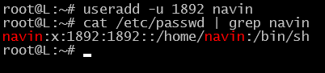

Adding group id 125

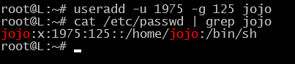

Adding soldier to multiple groups

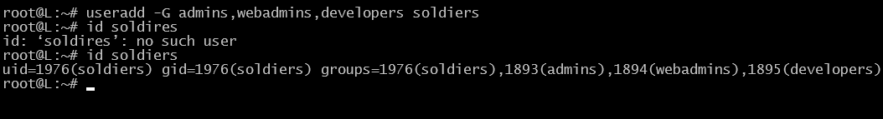

Creating users without home directory

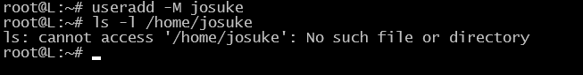

Creating users with account expiry date

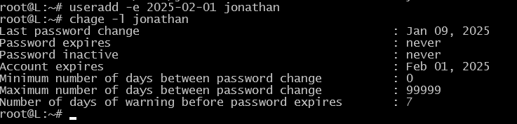

Password expiry date



Adding custom commands

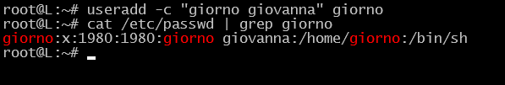

Change user login shell

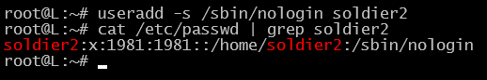

Adding user with specific home directory, default shell and custom comment



